Castle Point Mayors Awards 2026 Nomination form

If you have a major business success story or would like to nominate an exceptional business, please complete the below form and return to the Economic Development Team at the address below. One of the category winners will receive the prestigious Business of the Year Award.
We may contact you to arrange a site visit, should you be shortlisted.
Shortlisted entrants may be invited to attend a special celebratory networking event, before the Presentation Evening and Dinner on 17th April 2026.
Note: The trading address of the business must be based in the borough of Castle Point to apply.

YOUR DETAILS

Your Name:

Address:

Telephone:

Email:

BUSINESS DETAILS
Company Name:

Nature of Business:

Address:

Telephone:

Website:

Number of Years trading:

Total Number of Employees:

Estimated Annual Turnover/Profit last financial year:

Which category would you like to nominate the business for?:

Community Champion Creative Business Start-Up Business

Customer Service Green Business

ABOUT THE BUSINESS

Please provide a description of the business, and set out why they should win, along with some of its recent key achievements (maximum 500 words):

Please continue on a separate sheet if necessary

Please give an example, if you can, of any instances where the business has contributed to good causes within the local community (this could include sponsoring a local youth event, demonstrating particularly good ‘green’ credentials, etc.) (maximum 250 words):

Please continue on a separate sheet if necessary

Completed nomination forms should be returned by the Sunday 1st March 2026 to:

The Regeneration & Economic Development Team
Castle Point Borough Council
Kiln Road
Thundersley
Benfleet
Essex SS7 1TF
Email: business@castlepoint.gov.uk

The Economic Development and Regeneration team are here to support businesses in Castle Point to grow and flourish.


To find out about the wide range of business support on offer, visit: https://www.castlepoint.gov.uk/business-support-and-regeneration.
To sign up to Castle Point’s free business support e-newsletter, featuring fortnightly updates from the team, on the latest business support, funding, news, events and more: or scan the QR code

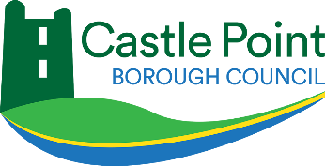

Thank you to all our category sponsors:





