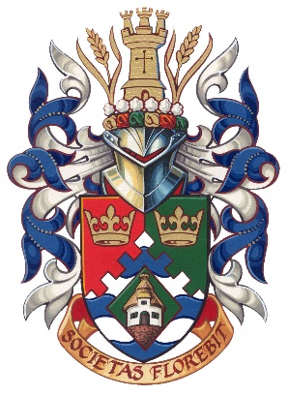

**NOMINATION FORM**

THE MAYOR’S AWARD

2024

RECOGNISING BUSINESS EXCELLENCE IN CASTLE POINT

CATEGORY: Green Business of the Year 2024

This category has been set up to recognise businesses, small or large, who have made the greatest efforts to reduce the environmental impact of themselves or their customers, and introduce more sustainable and innovative ways of working to the business.

The business could be based in any sector, be it one that is already working in a ‘green’ industry to one that has made considerable efforts to introduce sustainability throughout the business and the supply chain.

To nominate a business (it could be your own) for the Castle Point Green Business of the Year award, simply complete the details below and return to The Economic Development Team by the 22nd December 2023 at the address provided. **Note the business must be based within the borough of Castle Point to be accepted.**

YOUR DETAILS

Your Name:­­­­­­­­­­­­­­­­­­­

Address:

Telephone:

Email:

BUSINESS DETAILS

Company Name:­­­­­­­­­­­­­­­­­­­

Nature of Business:

Address:

Telephone:

Website:

Number of Years trading:

Total Number of Employees:

Estimated Annual Turnover/Profit last financial year:

Does the business have any sustainability certification?

E.g. ISO 14001, B Corp etc. Yes | No

ABOUT THE BUSINESS

Please explain why you think the business should win the title of ‘Green Business of the Year’

In your citation, you should give an example of where you have introduced new green practices to your business, and how It has benefitted the business. This could be through increased productivity, turnover, cost reduction, innovation etc (500 words maximum):

Can you demonstrate where the business has run any behavioral change campaigns or initiatives (raised employees and/or customers awareness of environmental issues) :

**Completed nomination forms should be returned by the 26th January 2024 to:**

The Regeneration & Economic Development Team

Castle Point Borough Council

Kiln Road

Thundersley

Benfleet

Essex SS7 1TF

Tel: 01268 882280

Email: [business@castlepoint.gov.uk](mailto:business@castlepoint.gov.uk)

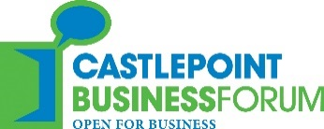** CastlePoint Logo

The Economic Development and Regeneration team are here to support businesses in Castle Point to grow and flourish.

To find out about the wide range of business support on offer, visit: <https://www.castlepoint.gov.uk/business-support-and-regeneration>.

If you would like to receive fortnightly updates from the team, updating you on the latest business support, news, events and more, just email [business@castlepoint.gov.uk](mailto:business@castlepoint.gov.uk).

**Issues of interest**

Tick those which you would like to hear more about

☐ Business networking events

☐ Business development support

☐ Castle Point Plan

☐ Finance & grants for businesses

☐ Apprenticeships

☐ Training and skills development

☐ Marketing & Social Media

☐ Community news and issues

☐ Mayor’s Awards

☐ Jobs and employment

☐ Licensing

☐ Transport

☐ Environment

☐ Utility issues: Water / Electricity / Gas /