Castle Point Mayors Awards 2025 Nomination form, Rising Star Award

If you would like to nominate an individual that you think deserves the accolade of “Rising Star” please complete the below form and return to the Economic Development Team at the address below.

*We may contact you to arrange a site visit.*

Shortlisted entrants will be invited to attend a special celebratory lunch with the Mayor of Castle Point, and other shortlisted businesses in March 2024.

*Note: The businesses trading address must be based in the borough of Castle Point to apply.*

YOUR DETAILS

Your Name:­­­­­­­­­­­­­­­­­­­

Address:

Telephone:

Email:

NOMINEE DETAILS

Persons Name: ­­­­­­­­­­­­­­­­­­­

Name and Nature of Business:

Address:

Telephone:

Website:

ABOUT THE BUSINESS

In the box below, please provide some information about the individual you are nominating for Young Businessperson of the year, and describe why you think they should win.

We would love to hear about this individuals story in business, how they have grown a successful business in Castle Point, and key achievements. We are also keen to hear about any acts of ‘giving back’ to the community and Innovation/new ideas.

(maximum 500 words):

*Please continue on a separate sheet if necessary*

**Completed nomination forms should be returned by the 21st February 2025 to:**

The Regeneration & Economic Development Team

Castle Point Borough Council

Kiln Road

Thundersley

Benfleet

Essex SS7 1TF

Tel: 01268 882280

Email: [business@castlepoint.gov.uk](mailto:business@castlepoint.gov.uk)

The Economic Development and Regeneration team are here to support businesses in Castle Point to grow and flourish.

To find out about the wide range of business support on offer, visit: <https://www.castlepoint.gov.uk/business-support-and-regeneration>.

To sign up to Castle Point’s free business support e-newsletter, featuring fortnightly updates from the team, on the latest business support, funding, news, events and more: or scan the QR code

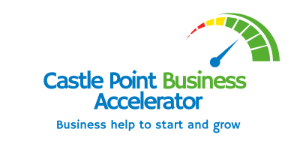 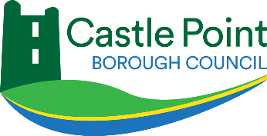

The Rising Star Award is proudly sponsored by USP College