Castle Point Mayors Awards 2025 Nomination form, Community Champion Award

If you would like to nominate an individual or business that you think deserves the accolade of best Community Champion please complete the below form and return to the Economic Development Team at the address below.

*We may contact you to arrange a site visit.*

Shortlisted entrants will be invited to attend a special celebratory lunch with the Mayor of Castle Point, and other shortlisted businesses in March 2024.

*Note: The businesses trading address must be based in the borough of Castle Point to apply.*

YOUR DETAILS

Your Name:­­­­­­­­­­­­­­­­­­­

Address:

Telephone:

Email:

NOMINEE DETAILS

Persons Name: ­­­­­­­­­­­­­­­­­­­

Name and Nature of Business:

Address:

Telephone:

Website:

ABOUT THE PERSON

In the box below, please provide some information about the individual you are nominating for Community Champion of the year, and describe why you think they should win.

This Award recognises an individual in business who goes above and beyond, outside of the day-to-day running of their business. We would love to hear about this individuals story in business, and how they have made a significant positive impact to their local community in the past year.

(maximum 500 words):

*Please continue on a separate sheet if necessary*

**Completed nomination forms should be returned by the 21st February 2025 to:**

The Regeneration & Economic Development Team

Castle Point Borough Council

Kiln Road

Thundersley

Benfleet

Essex SS7 1TF

Tel: 01268 882280

Email: [business@castlepoint.gov.uk](mailto:business@castlepoint.gov.uk)

The Economic Development and Regeneration team are here to support businesses in Castle Point to grow and flourish.

To find out about the wide range of business support on offer, visit: <https://www.castlepoint.gov.uk/business-support-and-regeneration>.

To sign up to Castle Point’s free business support e-newsletter, featuring fortnightly updates from the team, on the latest business support, funding, news, events and more: or scan the QR code

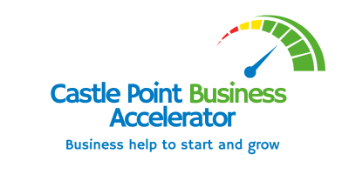 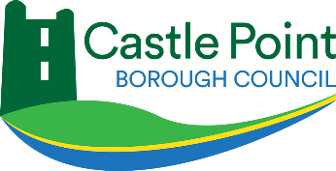

The Community Champion Award is proudly sponsored by Fi911 Chargebacks