Castle Point Mayors Awards 2025 Nomination form

If you have a major business success story or would like to nominate a business that you think deserves the accolade of “Mayors Choice”, please complete the below form and return to the Economic Development Team at the address below.

*We may contact you to arrange a site visit, should you be shortlisted.*

Shortlisted entrants may be invited to attend a special celebratory networking event, before the Presentation evening at the Mayor’s Civic Dinner on 4th April 2025.

*Note: The trading address of the business must be based in the borough of Castle Point to apply.*

YOUR DETAILS

Your Name:­­­­­­­­­­­­­­­­­­­

Address:

Telephone:

Email:

BUSINESS DETAILS

Company Name:­­­­­­­­­­­­­­­­­­­

Nature of Business:

Address:

Telephone:

Website:

Number of Years trading:

Total Number of Employees:

Estimated Annual Turnover/Profit last financial year:

**Which category would you like to nominate the business for?:**

Business of the year Community Champion Start-up Business

Creative Business Retailer of the Year Tech Business

Small Business Employer of the Year

ABOUT THE BUSINESS

Please provide a description of the business, and set out why they should win, along with some of its recent key achievements (maximum 500 words):

*Please continue on a separate sheet if necessary*

Please give an example, if you can, of any instances where the business has contributed to good causes within the local community (this could include sponsoring a local youth event, demonstrating particularly good ‘green’ credentials, etc.) (maximum 250 words):

*Please continue on a separate sheet if necessary*

**Completed nomination forms should be returned by the 21st February 2025 to:**

The Regeneration & Economic Development Team

Castle Point Borough Council

Kiln Road

Thundersley

Benfleet

Essex SS7 1TF

Tel: 01268 882280

Email: [business@castlepoint.gov.uk](mailto:business@castlepoint.gov.uk)

The Economic Development and Regeneration team are here to support businesses in Castle Point to grow and flourish.

To find out about the wide range of business support on offer, visit: <https://www.castlepoint.gov.uk/business-support-and-regeneration>.

To sign up to Castle Point’s free business support e-newsletter, featuring fortnightly updates from the team, on the latest business support, funding, news, events and more: or scan the QR code

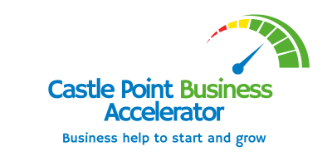 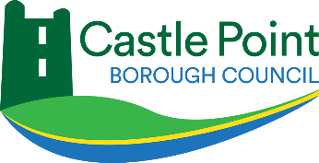

Thank you to all our category sponsors:

